Importing Word Files with Respondus 4.0
Respondus 4.0 is loaded with features, so you never know which ones will resonate with a new user. But the one that makes the most people smile is the “Question Import” task. This is where a test already in MS Word format can be imported into Respondus 4.0. And if you have MS Word 2007 installed (using the .docx format), the importing process is even more impressive.
Let’s face it, nobody enjoys copying and pasting assessment questions from a word processor into a learning management system. The process is even more time-consuming if the questions have tables, images, equations and other types of formatting. But with minimal adjustments to the MS Word file, Respondus 4.0 can import these questions and most of the advanced formatting contained in the questions. Then you’re just a few clicks away from publishing the assessment to the learning management system.
Consider this question:
1) Determine the area of the shaded portion in the diagram below.
• ABCD is a square
• ABCD touches the circle at 4 points
• The length of one side of the square ABCD is 2 cm
a. π– 4
b. 2π – 4
c. 3π² – 4
d. 4π³ – 4
e. 5π – 4
With Respondus 4.0, you can import dozens of questions like these in seconds. If that sounds like hyperbole, try it yourself. Download this Word 2007 file (.docx) which contains 10 questions and a variety of tables, images and equations:
Download Sample File
Then start Respondus 4.0 and follow the steps below. (If you don’t have a copy of Respondus 4.0, you can download the free, 30-day trial version.)
- If you opened the file in MS Word, close it now. (Windows doesn’t allow two programs to simultaneously access a file.)
- Start Respondus 4.0, and select “Import Questions” from the Start tab.
- Under Type of file, select “Microsoft Word 2007 [DOCX]”
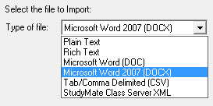
(Note: MS Word 2007 needs to be installed to this same computer.)
- Browse to the MS Word file and select it.
- Provide a name for the file being created in Respondus.
- Click the Preview button to check for errors (there won’t be any with this file!). Then, click Finish.
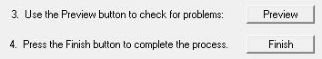
The file is now imported and ready to be published to a learning management system.
Give it a try. Better yet, have someone else try it. And watch the smile come across their face.

